Naturalis Healing – Booking Form
All information is held in strictest confidence.
At no given point is information disclosed or shared.
Invoicing Details
- Name *
Address *
Email Address *
Physical Treatment Address: * (we may charge travel cost) * Suburb*
Postal Code*

Tel No’s
Preferred day(s) and time(s)

Click or tap to enter a date.

Click or tap to enter a date.

For: 1 Person ☐ Female ☐ Male ☐ Age 00
2nd Person ☐ Female ☐ Male ☐ Age 00

*Foot Scrub☐ *Foot Massage☐ *Hand Scrub☐ *Hand Massage☐
*Face Massage☐ *Head Massage☐ *Pack of Healing Stones ☐
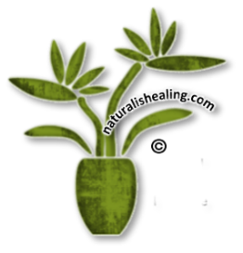

Special Requirements / Requests

Current General Health:

Person 1 - Good ☐ Poor ☐

Person 2 - Good ☐ Poor ☐

If your health is poor, please briefly describe your problem(s)

Person 1

Person 2

I am submitting the form for someone I would like a gift voucher for: ☐

Gift Voucher to be issued for Name(s)

We will email the Gift Voucher upon receipt of payment.
Please refer the person(s) the Gift Voucher is for to contact us or use the
Gift Voucher Booking form.
